Statistical Analysis and modelling of Starbucks

**Pranjal Chakraborty**   
*Computer Science &*

*Engineering*

*Meghnad Saha Institute of Technology*

*(Aff. To MAKAUT)*

*Kolkata, India*

*pranjalchakraborty2003@gmail.com*

**Madhurima Kumari**   
*Computer Science &*

*Engineering*

*Meghnad Saha Institute of Technology*

*(Aff. To MAKAUT)*

*Kolkata, India*

*madhurimamishra2222*

*@gmail.com*

**Enakshi Nahar**   
*Computer Science &*

*Engineering*

*Meghnad Saha Institute of Technology*

*(Aff. To MAKAUT)*

*Kolkata, India*

*enakshinahar2003*

*@gmail.com*

**Arya Chatterjee**  
*Computer Science &*

*Engineering*

*Meghnad Saha Institute of Technology*

*(Aff. To MAKAUT)*

*Kolkata, India*

*aryachatterjee8831official@gmail.com*

**Devasmita Kundu**   
*Computer Science &*

*Engineering*

*Meghnad Saha Institute of Technology*

*(Aff. To MAKAUT)*

*Kolkata, India*

*kdevasmita@gmail.com*

*Abstract - This paper aims to analyze some of the different aspects of Starbucks from their stocks, nutritional facts, and consumer data. This case study analyzes data provided by Starbucks that simulates their customer demographics and transactional activities during a promotional campaign. The purpose of this case study is to understand customer response to different offers in order to come up with better approaches to sending customers specific promotional deals. Customer segmentation also provides insights on new customer targeting. Starbucks uses powerful data science and analytics beans to brew each cup of coffee to improve their customer experience and service performance. All the conclusions drawn from the datasets as mentioned above have been condensed into this paper.*

Keywords - EMA, SMA, Financial Analysis, Technical Indicators, Customer Purchase Behavior, Consumer Demographics

GitHub Repository Link – [click here](https://github.com/arya8831/Starbucks-Data-Analysis.git)

# **Stock Performance Analysis**

To analyze Starbucks' stock performance, we collected historical stock data from reliable sources, ensuring data consistency and completeness. The data was then preprocessed to handle any missing values or irregularities.

## **Data Collection and Preprocessing :**

For data collection and historical stock data for Starbucks was collected from reliable sources such as Yahoo Finance or financial APIs. The data was then preprocessed to ensure data consistency and handle any missing values or irregularities that could affect the analysis. Data preprocessing involved tasks such as removing duplicate entries, handling missing data points, and converting date columns into a proper date format for ease of analysis.

## **Trend Analysis :**

The trend analysis of Starbucks' stock involved visualizing the closing price and volume of the stock over time. A line plot was created to illustrate the historical trend of the stock's closing prices, revealing how the stock's value has evolved over the entire time period under consideration. This visualization allowed us to identify potential long-term trends, such as upward or downward movements, as well as any seasonal or cyclical patterns that might be influencing the stock's performance.

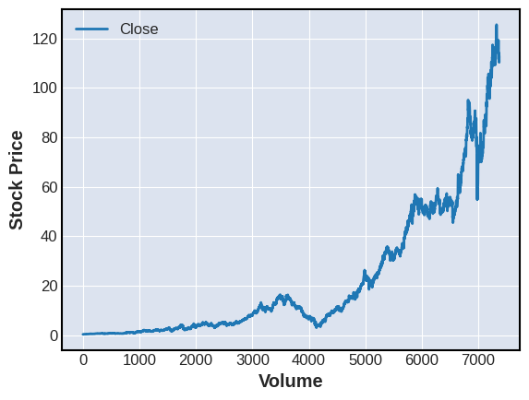

Furthermore, a line plot of the stock's trading volume over time was generated to examine the level of market activity. Changes in trading volume could indicate significant events or shifts in investor sentiment that may affect the stock's price movements. By analyzing both the closing price and trading volume together, we aimed to identify potential correlations and gain insights into the stock's overall liquidity and market participation.

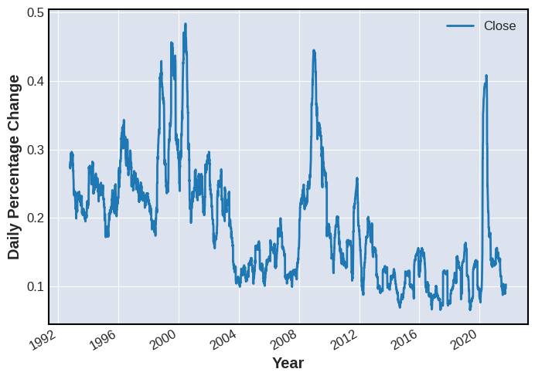

## ***Moving Averages :***

Moving averages are powerful technical indicators used by investors and traders to identify trends and potential trading opportunities. In our analysis, we computed both Simple Moving Averages (SMA) and Exponential Moving Averages (EMA) of the stock's closing price.

On the other hand, the Exponential Moving Average (EMA) places more weight on recent data points, making it more sensitive to recent price changes. This feature allows the EMA to respond more quickly to price movements, making 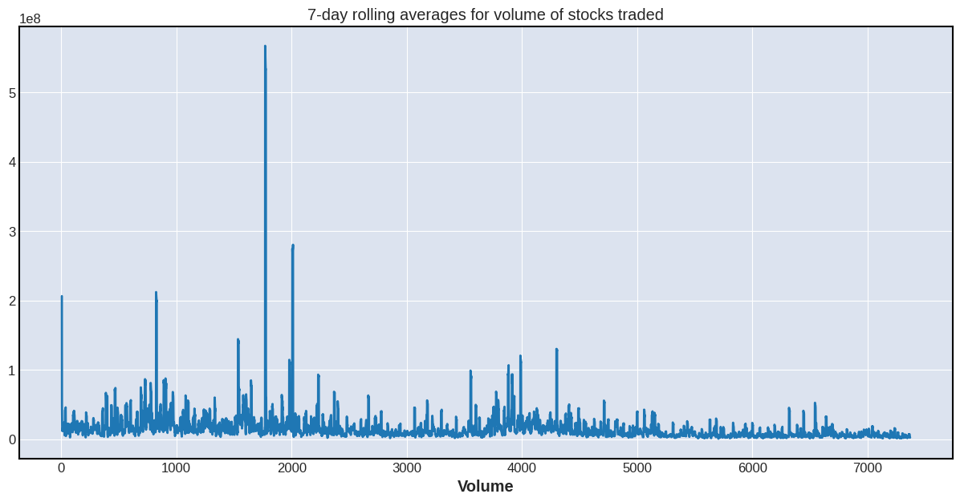it a popular choice for short-term trading strategies.

By visualizing both the stock's price data and its corresponding SMAs and EMAs, we sought to identify crossover points and potential buy/sell signals based on the moving average strategies.

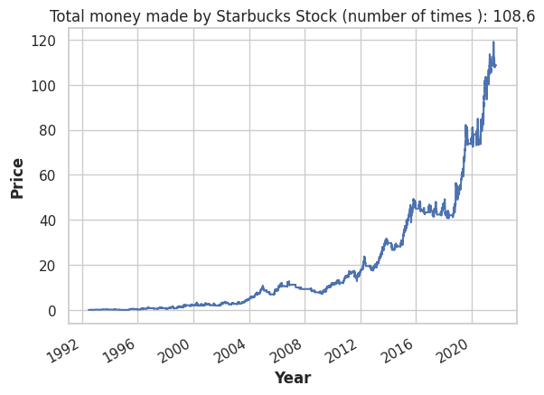Overall, the stock performance analysis provided valuable insights into Starbucks' market performance, trends, and potential trading opportunities for investors and traders alike. The combination of visualizations and quantitative metrics allowed us to make informed decisions based on historical data and technical indicators.

# **Nutritional Facts Analysis**

For the nutritional facts analysis, we collected data on Starbucks' menu items and their corresponding nutritional information from reliable sources. This data included details such as calories, total fat, saturated fat, trans fat, cholesterol, sodium, total carbohydrates, dietary fiber, sugars, protein, vitamins, calcium, iron, and caffeine content for each menu item.

Data preprocessing was essential to ensure the accuracy and consistency of the nutritional data. We handled missing values, standardized the units, and converted relevant columns to numerical format for ease of analysis. Additionally, some columns contained textual units (e.g., "g" for grams) or percentage symbols, which were removed to convert the data into numeric values.

## **Nutritional Analysis and Visualization :**

### Highest Calorie Drinks and Foods :

To gain insights into Starbucks' menu offerings, we first analyzed and visualized the highest-calorie drinks and foods. We sorted the menu items by calorie content in descending order to identify the most calorie-dense options. This analysis allowed us to identify which items contributed the most to the total calorie intake when consuming Starbucks products.

A bar plot was created to display the top 20 menu items with the highest calorie content. This visualization provided a quick overview of the most calorically dense drinks and foods available at Starbucks.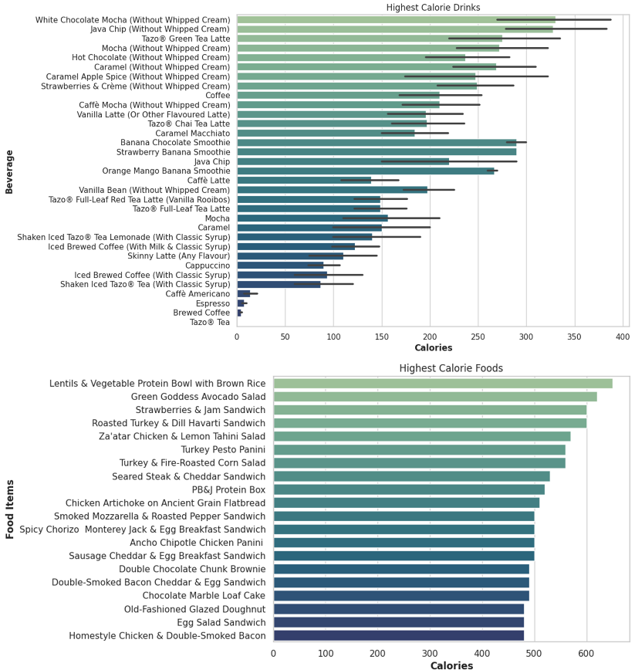

### Average Calories per Beverage Category :

Next, we explored the average calorie content for different beverage categories to understand the nutritional profile of Starbucks' drinks. A bar plot was generated to display the average calorie content for each beverage category, such as coffee, tea, and other specialty beverages.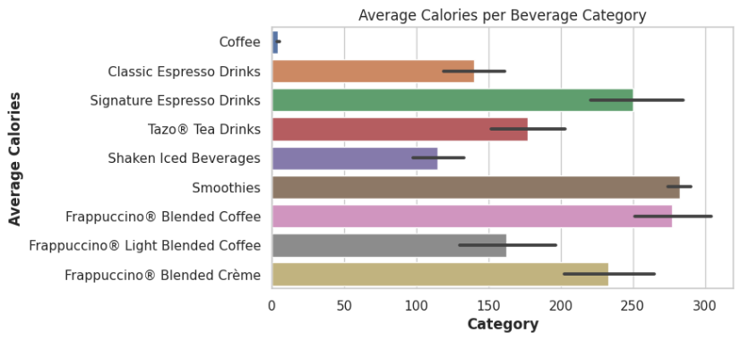

This analysis helped us understand which beverage categories tend to be higher or lower in calorie content. It also provided insights into potential healthier beverage choices for customers conscious of their calorie intake.

### Correlation Between Calories and Cholesterol :

To explore potential correlations between different nutritional components, we performed a joint distribution analysis of calories and cholesterol content in Starbucks' menu items. This involved generating a scatter plot with a regression line to visualize the relationship between calories and cholesterol.

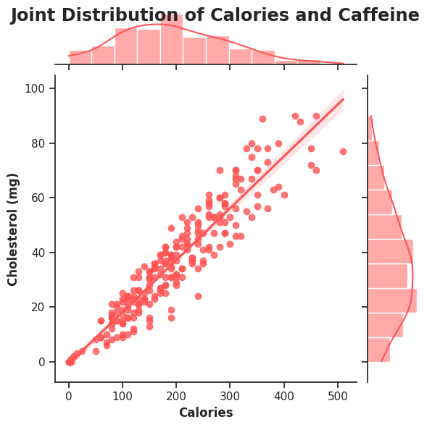

By examining the scatter plot, we were able to determine whether higher-calorie menu items tended to have higher cholesterol content or vice versa. This analysis provided insights into any potential associations between these two nutritional factors.

### Caffeine Content by Beverage Category :

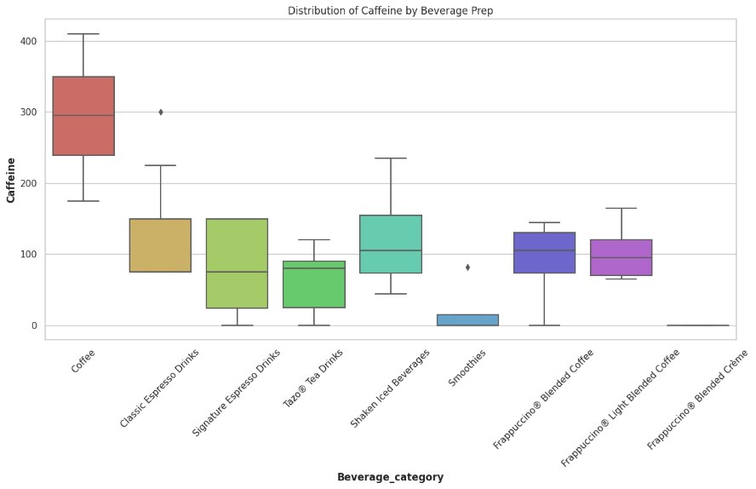Additionally, we investigated the caffeine content across different beverage categories. A box plot was created to display the distribution of caffeine levels in each beverage category, allowing us to compare the caffeine content between various types of drinks.

This analysis helped customers and health-conscious individuals identify the relative caffeine levels of different Starbucks beverages and make informed choices based on their caffeine preferences or restrictions.

### Insights and Recommendations :

The nutritional facts analysis of Starbucks' menu items provided valuable insights into the overall nutritional profile of their products. By understanding the calorie content, caffeine levels, and nutrient composition of various items, customers can make informed decisions based on their dietary preferences and health goals.

Overall, the nutritional facts analysis offers a comprehensive understanding of Starbucks' menu offerings and serves as a valuable resource for customers aiming to make mindful and informed choices while enjoying their favorite Starbucks products.

# **Consumer Behavior Analysis**

The consumer behavior analysis involves understanding the interactions between Starbucks' customers and the promotional offers they received. We collected data from different sources, including the customer profile data, offer details, and transaction records. It was crucial to ensure that the data was accurate and consistent before proceeding with the analysis.

To prepare the data for analysis, we performed data cleaning and preprocessing. This involved handling missing values, removing duplicate records, and formatting data types for better compatibility. By cleaning the data, we ensured that the analysis is based on reliable information, reducing the risk of drawing incorrect conclusions.

## **Consumer Demographics :**

Studying the demographics of Starbucks customers involved analyzing data on age, gender, location, and other relevant demographic factors. By segmenting the customer base, we identified patterns and preferences among different demographic groups

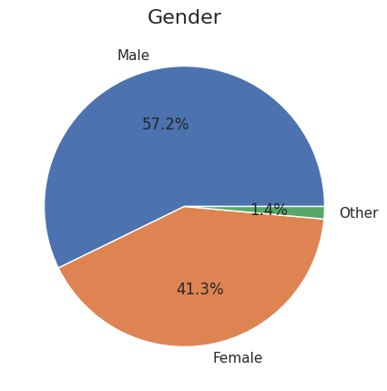

Understanding the demographics of Starbucks' clientele is crucial for tailoring marketing strategies and developing products that cater to specific 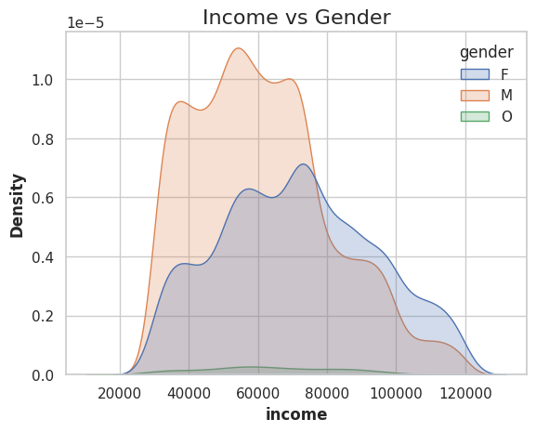customer segments.

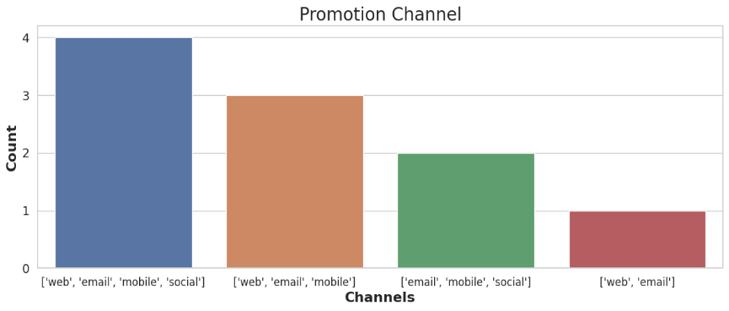For example, if the data showed that a significant proportion of customers were young adults, Starbucks might focus on social media marketing to target this audience effectively. One of the key aspects of the analysis was to study how customers responded to the promotional offers sent by Starbucks.

We tracked three main events related to offers such as offer received, offer viewed, and offer completed. By analyzing these events, we gained insights into customers' engagement and conversion rates.

We calculated the number of offers received, viewed, and completed for each customer. This allowed us to determine how many offers were successfully received by customers, how many of those offers were viewed, and how many resulted in successful completions (offer completion).

## **Customer Purchase Behavior :**

To gain a deeper understanding of customer purchase behavior, we analyzed data on frequency of visits, popular visiting hours, and average spending per visit. This information provided insights into how often customers visit Starbucks, the peak hours of business, and the overall sales potential.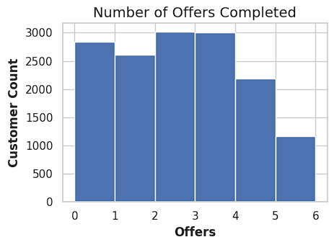

By knowing the average spending per visit, Starbucks can optimize pricing strategies and create attractive loyalty programs to encourage repeat visits and higher spending from customers. Additionally, identifying peak hours helps the company manage staff and resources efficiently, ensuring a smooth customer experience during busy periods.

## **Insights and Recommendations :**

The consumer behavior analysis provided valuable insights into the preferences, choices, and expectations of Starbucks customers. By leveraging this information, Starbucks can make informed decisions to enhance customer satisfaction, drive sales, and strengthen brand loyalty.

Based on the analysis, Starbucks can implement the following recommendations:

* Personalized Marketing: Utilize customer demographics data to tailor marketing campaigns and promotions to specific customer segments. Personalized marketing efforts can increase engagement and resonance with the target audience.
* Menu Optimization: Leverage customer preferences and item popularity data to optimize the menu offerings. Highlighting customer-favorite items and refining less popular ones can lead to increased sales and improved customer satisfaction.
* Enhanced Loyalty Program: Continuously improve the loyalty and rewards program based on data insights. Offer enticing rewards and incentives that align with customer preferences to foster long-term loyalty.
* Seasonal Offerings: Introduce seasonal and regional-specific menu items to cater to local tastes and capitalize on seasonal demand. Limited-time offers can create a sense of urgency and excitement among customers.
* Social Media Engagement: Actively monitor and engage with customers on social media platforms to address feedback, respond to reviews, and build a positive brand image. Social media sentiment analysis can help gauge customer satisfaction and sentiment.

By integrating the findings from the consumer behavior analysis into their business strategies, Starbucks can strengthen its position in the market, foster customer loyalty, and sustainably grow its customer base.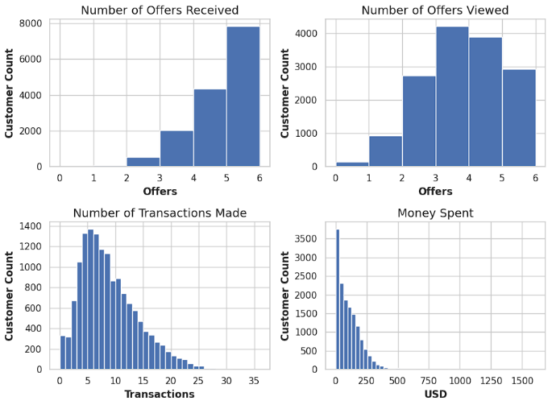

##### **Acknowledgments**

On behalf of our accomplished team, we extend our heartfelt gratitude to our dear friends whose unwavering support and encouragement have been instrumental in the success of this project. Your belief in us and constant motivation have been pivotal throughout our journey. We would also like to express our profound appreciation to our esteemed mentors and advisors for their invaluable guidance and expertise. Their wisdom and encouragement have steered us in the right direction, ensuring the quality and depth of our research. To all our team members, your dedication, expertise, and seamless collaboration have been indispensable in achieving our goals. Together, we share this success with our friends, mentors, and team members, and we are sincerely thankful for their unwavering support on this remarkable journey.

##### **References**

1. [McKinney, W., & others. (2010). Data structures for statistical computing in python. In Proceedings of the 9th Python in Science Conference (Vol. 445, pp. 51–56).](https://pandas.pydata.org/docs/)
2. [Harris, C.R., Millman, K.J., van der Walt, S.J. et al. Array programming with NumPy. Nature 585, 357–362 (2020). DOI: 10.1038/s41586-020-2649-2.](https://numpy.org/)
3. [J. D. Hunter, "Matplotlib: A 2D Graphics Environment", Computing in Science & Engineering, vol. 9, no. 3, pp. 90-95, 2007.](https://matplotlib.org/stable/index.html)
4. [Pedregosa, F., Varoquaux, Ga"el, Gramfort, A., Michel, V., Thirion, B., Grisel, O., … others. (2011). Scikit-learn: Machine learning in Python. Journal of Machine Learning Research, 12(Oct), 2825–2830.](https://scikit-learn.org/stable/)